Project Data Warehousing

Phase 2

TA: Ahmed Galal

|  |  |
| --- | --- |
| Name | ID |
| Nourhan Amr Abelwahab | 20201203 |
| Aya Hasanin Sayed | 20201041 |
| Mahmoud Sayed Ashore | 20200498 |
| Ismail Elsayed Mohamed | 20200084 |
| Samuel Milad Younan | 20210561 |

2. Data Flow Task and Control Flow

1. Customer Control flow

2. Customer Data flow from SRC to STG

3. Customer data flow from STG to DWH

4. Store Control flow

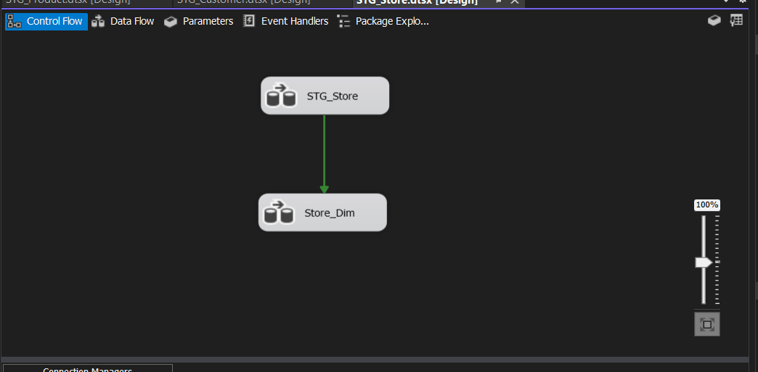

5. Store data flow from SRC to STG

6. Store data flow from STG to DWH

6. Product control flow

7. Product data flow From Source to STG

8. Product data flow From STG to DWH

9. Region control flow

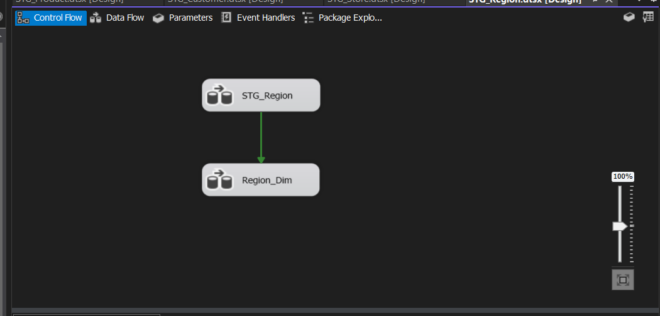

10. Region data flow from SRC to STG

12. Payment Strategy Control flow

13. Payment Strategy data flow from SRC to STG

14. Payment Strategy data flow from STG to DWH

15. Control flow for Inventory Fact Table

16. Order data flow from SRC to STG

17. Inventory Fact Table from Order STG to DWH

18. Revenue Fact Table Control flow

19. Revenue Fact Table Data flow form Order STG to DWH

20. Sales Fact Table Control flow

21. Sales Fact Table data flow from order STG to DWH

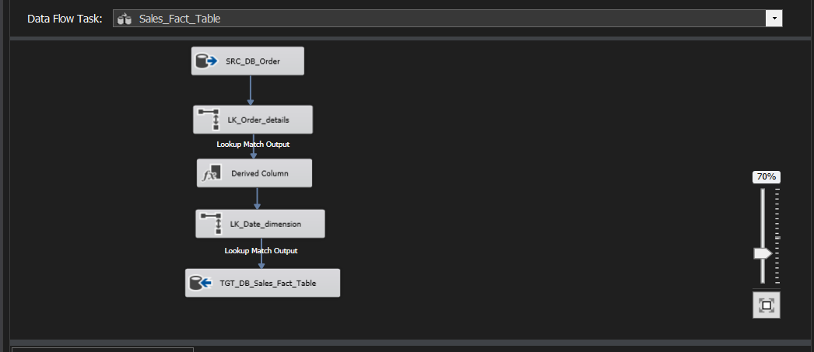

22. Payment Fact Table Control flow

23. Payment Fact Table data flow from STG to DWH

2. Queries on Fact Tables

1. Sales Fact Table

* Quantity purchased of each product to each customer monthly basis.

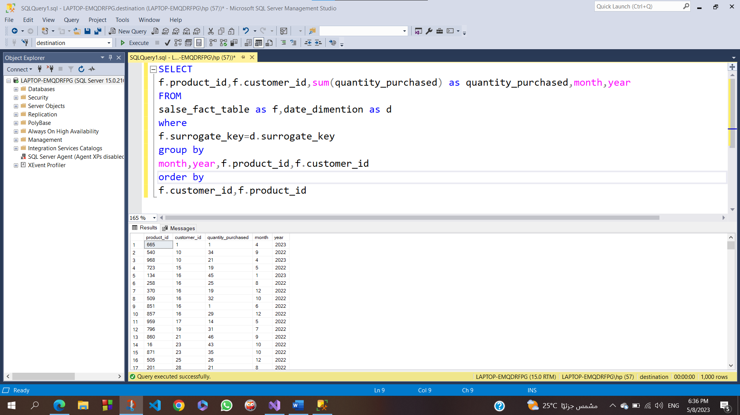

2. Inventory Fact Table

* The Quantity purchased for each product in a specific store monthly basis.

3. Revenue Fact Table

* Revenue of each product in each store monthly basis.

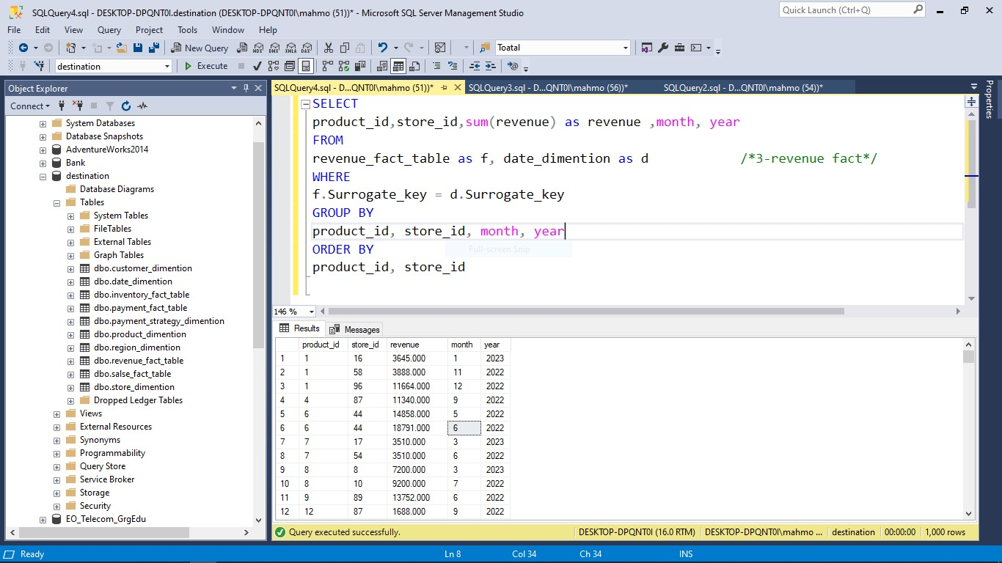

4. Payment Fact Table

* Count the Customers from each Region to pay with a Specific Payment Strategy monthly basis (Factless Fact Table).

3. Deployment

The Scheduler

1.

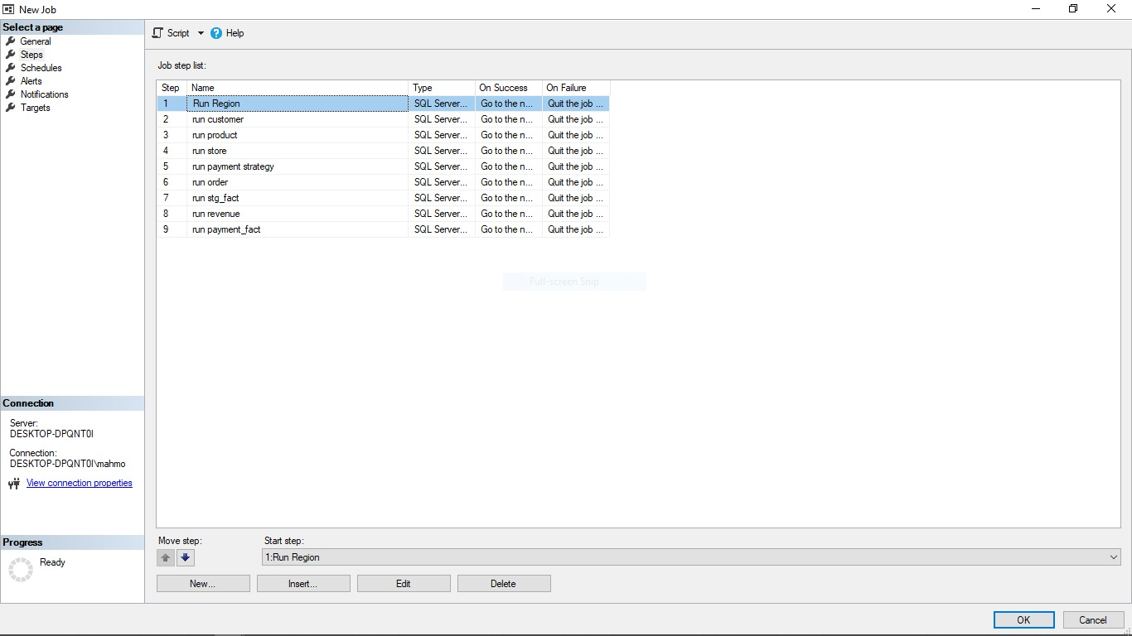

2.

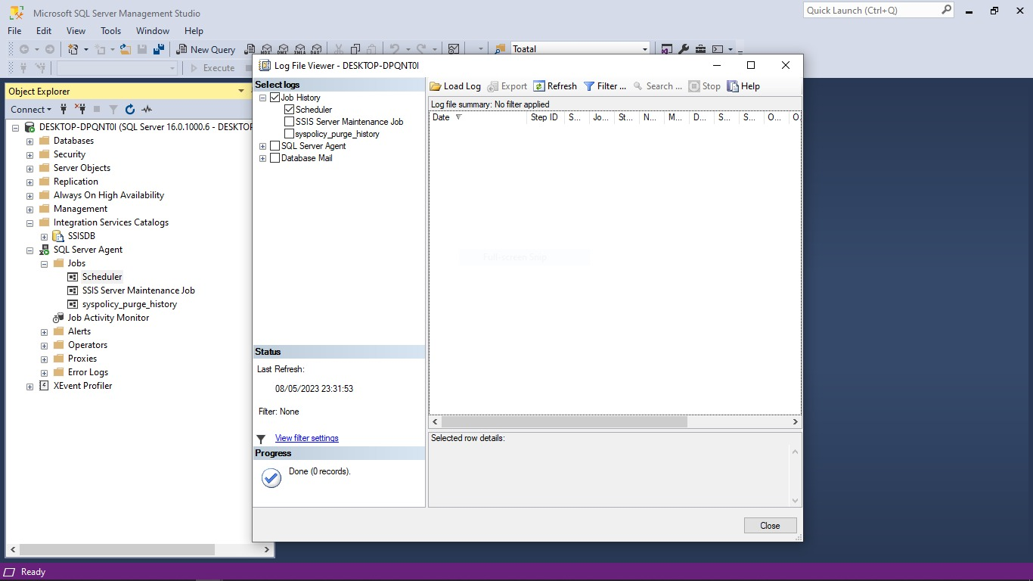

4. Dashboard For Source

1. Sum of quantity by customer id filtered by gender

2. Sum of quantity by customer id filtered by Female

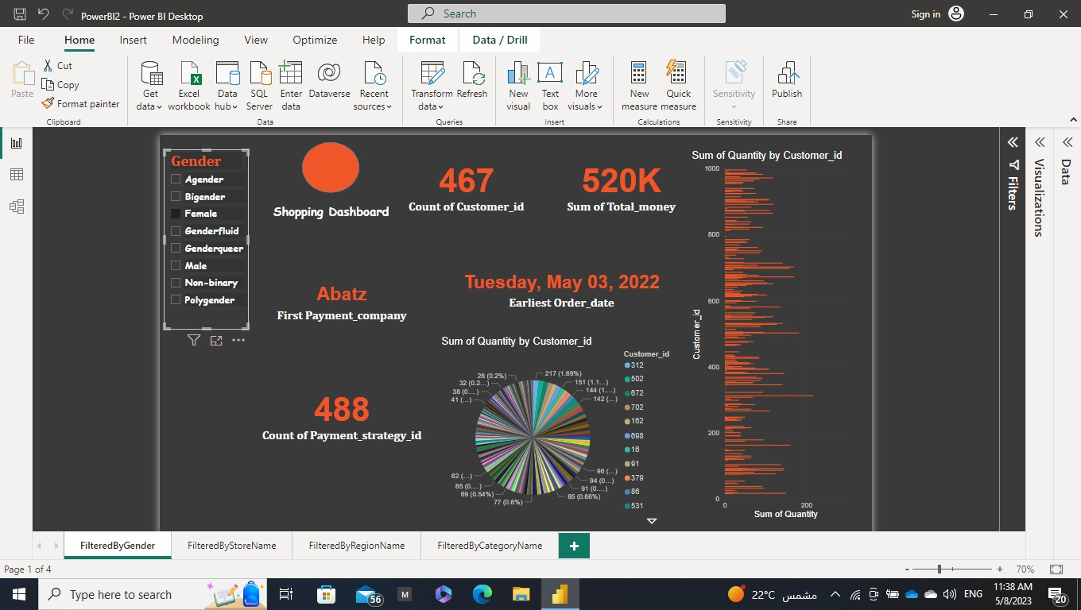

3. Sum of quantity by customer id filtered by Male

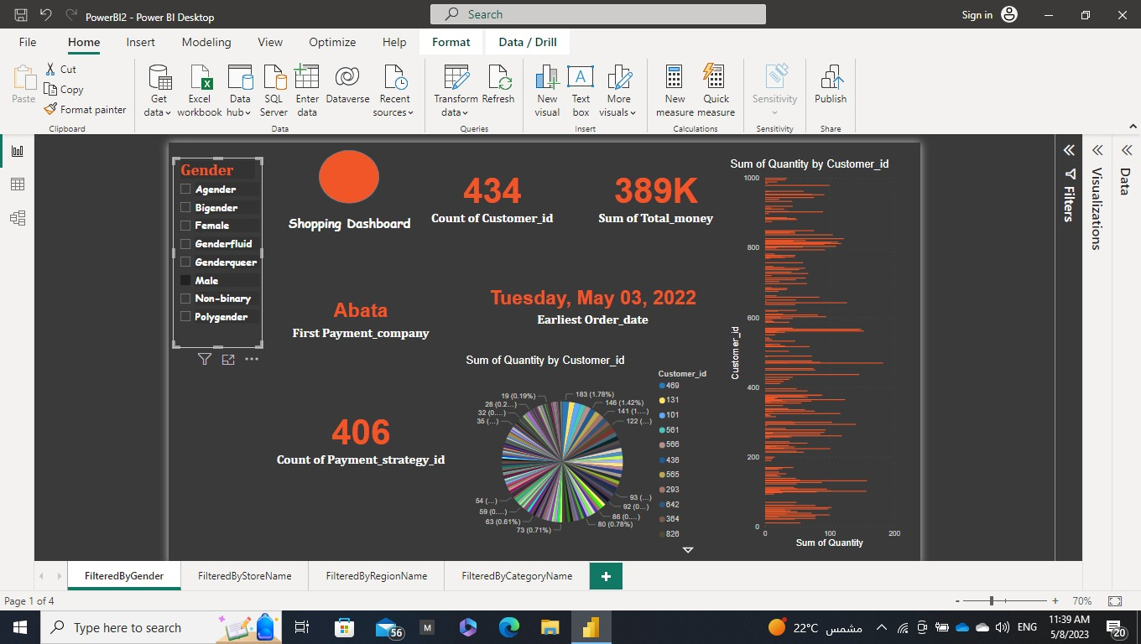

4. Sum of quantity by Product id filtered by store name

5. Sum of quantity by Product id filtered by store name AVXL

6. Sum of quantity by Product id filtered by store name CBK

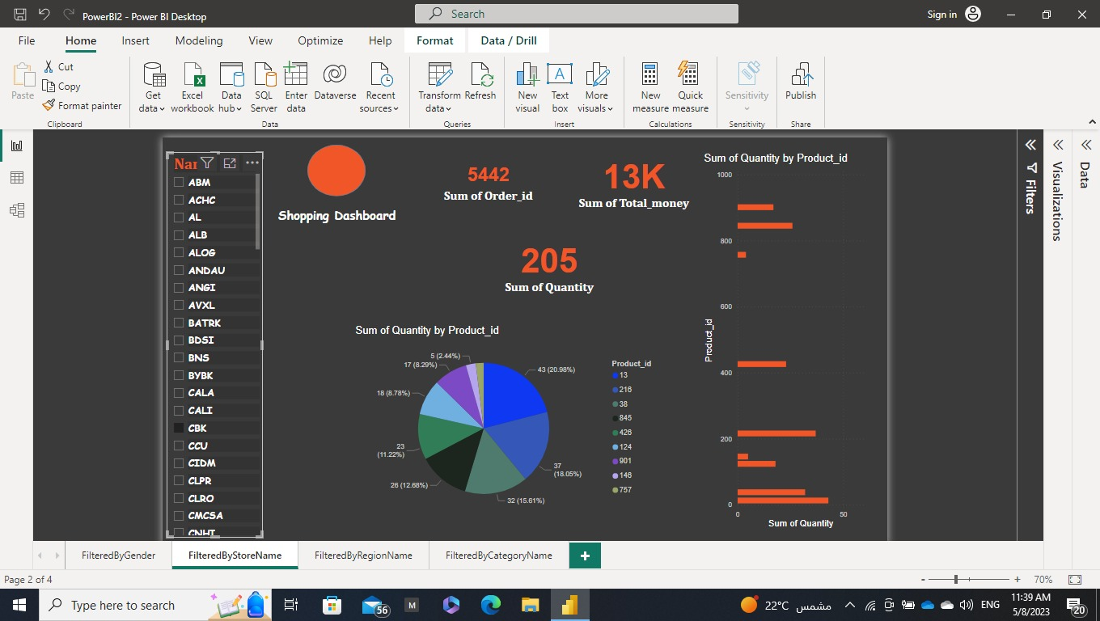

7. Sum of quantity by Store id filtered by region name

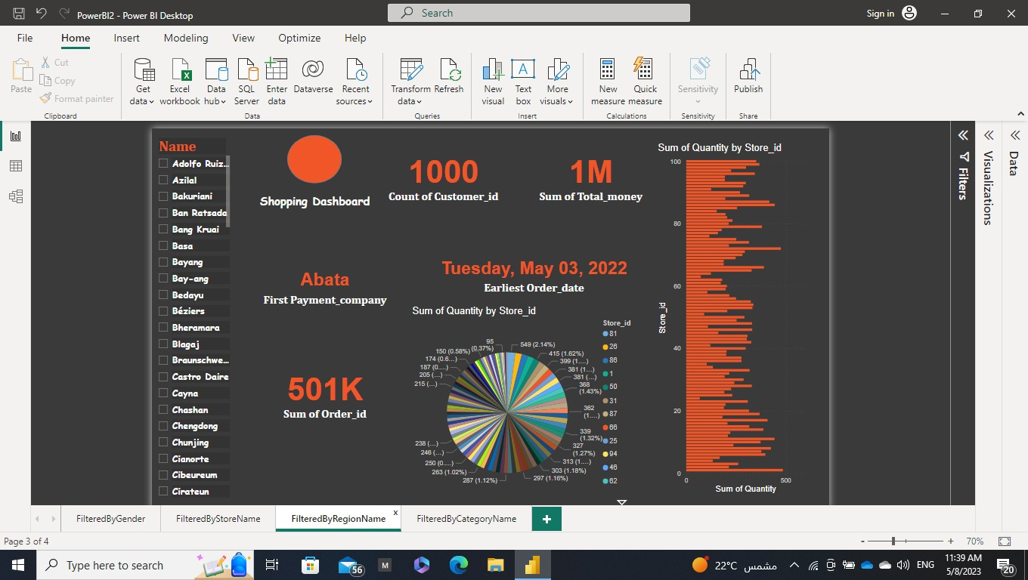

8. Sum of quantity by Store id filtered by region name basa

9. Sum of quantity by Store id filtered by region name Blagoj

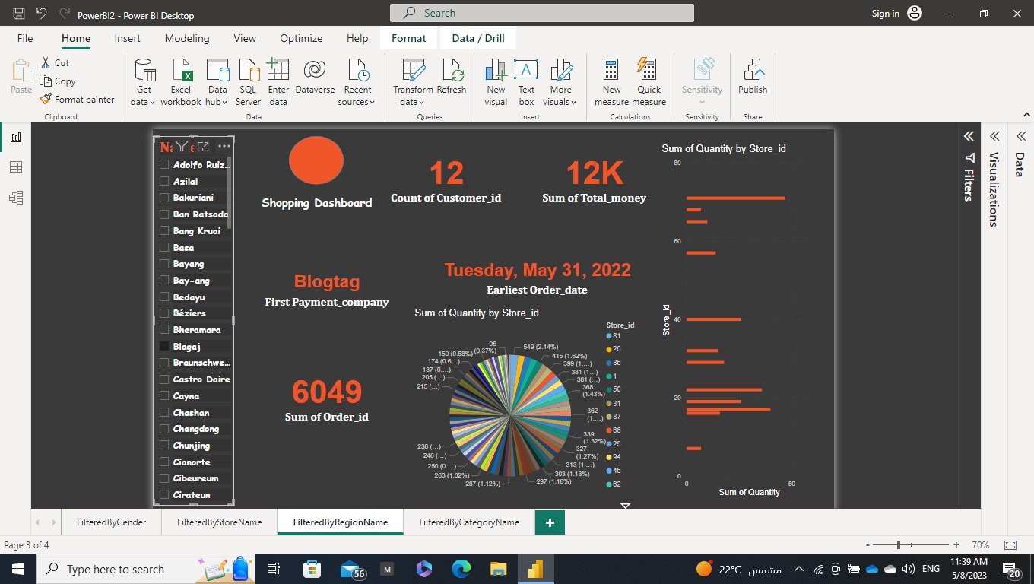

10. Sum of quantity by Category id filtered by Category name

11. Sum of quantity by Category id filtered by Category name II

12. Sum of quantity by Category id filtered by Category name Jr

4. Dashboard for DWH

* Query for Inventory Fact Table

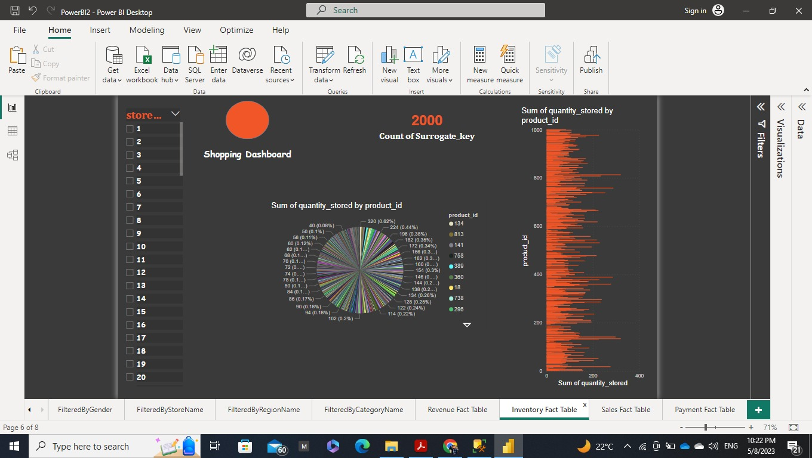

* Query for Sales Fact Table

* Query for Revenue Fact Table

* Query for Payment Fact Table

